To use a USB Flash Drive or SD card with a µEZGUI, it must be properly formatted to a supported file system and block size.

Currently out of the box µEZ supports the following file systems and block sizes:

* FAT32 / 4096 byte block size for drives 16GB or less
* FAT / 4096 byte block size for really small file systems

exFAT support requires modifications to µEZ. Please refer to the documentation for your specific µEZ version for details.

# Formatting drives in Linux

When using Linux follow the below steps to format the SD card or USB Flash Drive:

* First identify the drive letter of your Flash drive. For example, if your drive is “sdg” (shown below) the letter will be ‘g’.
  + Using a GUI tool such as the “gnome-disk-utility” you will see the drive letter on the right side under the window heading and also at the “Device” text.

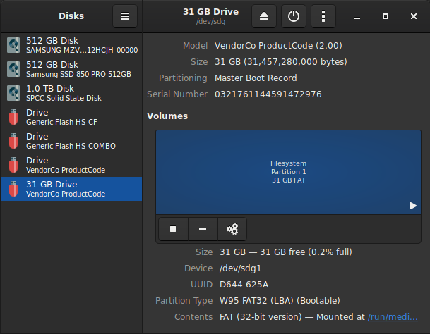

**Identifying the USB Flash drive as drive letter ‘g’**

* This letter will replace the capital ‘X’ in the below commands.
* Run the following commands either using sudo or as a root user:
  + sudo umount /dev/sdX1
  + sudo mkfs.vfat -v -F 32 -n 'DRIVE' /dev/sdX1
* The drive is now ready to use.

# Formatting drives in Windows

When using Windows follow the below steps to format the SD card or USB Flash Drive:

* Open File Explorer
* Select the drive letter for the SD card or USB Flash drive.
* Right click on the drive.
* Select the “Format…” Option

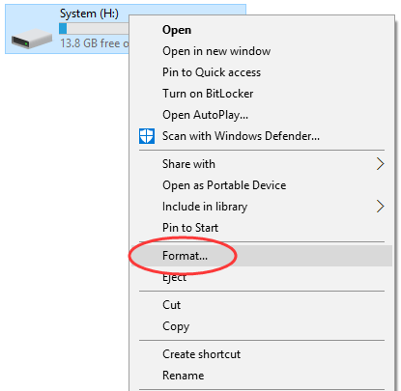

**Selection “Format…” in the dialog menu**

* Select the “FAT32“ option for the file system

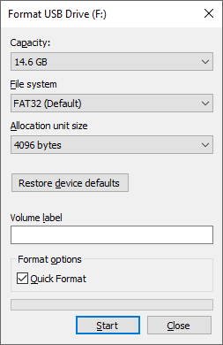

**Format Dialog Box**

* Select the “4096 byte” size under “Allocation unit size”.
* Click <Start>.
* The drive is now ready to use.